Name: Puna Poudel

Assignment: Module 5.2

Due Date: 6/23/2024

Professor: Chandra

Github url: <https://github.com/punaram14/csd-310.git>

1. CURRENT_DATE() Function

The `CURRENT_DATE()` function is used to retrieve the current date in the format `YYYY-MM-DD`. This can be useful in applications where you need to log the current date or filter records based on the current date.

Alias Example: `Today's Date`

SQL Statement:

SELECT CURRENT_DATE() AS 'Today\'s Date';

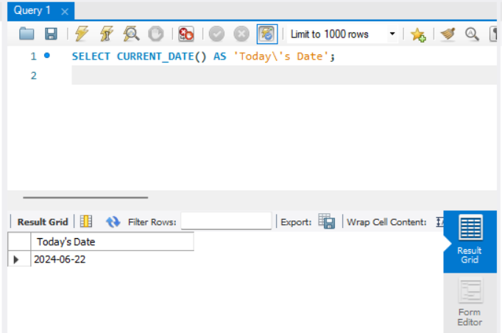

2. CONCAT() Function

The `CONCAT()` function is used to concatenate two or more strings into a single string. This can be useful for creating full names from first and last names, combining address fields, or generating custom messages.

Alias Example: `FullName`

SQL Statement:

SELECT CONCAT(first_name, ' ', last_name) AS FullName FROM employees;

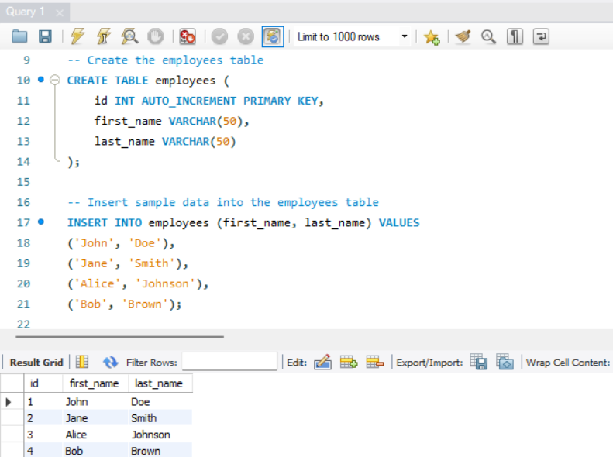

3. ROUND() Function

The `ROUND()` function is used to round a numeric field to the number of decimals specified. This is useful for financial calculations where you need to round to the nearest cent or for reporting purposes to display rounded figures.

Alias Example: `RoundedPrice`

SQL Statement:

SELECT ROUND(price, 2) AS RoundedPrice FROM products;

Link: <https://www.w3schools.com/mysql/mysql_alias.asp>